Project Design Phase-II
Technology Stack (Architecture & Stack)
Date | 31 January 2025
Team ID | Team-BMS-2025
Project Name | Bookstore Management System (MERN Stack)
Maximum Marks | 4 Marks

Technical Architecture
The Bookstore Management System follows a three-tier MVC architecture built on the MERN stack. The diagram below shows the flow between the user-facing frontend, the Express.js backend services, MongoDB data storage, and external services for payments and notifications.
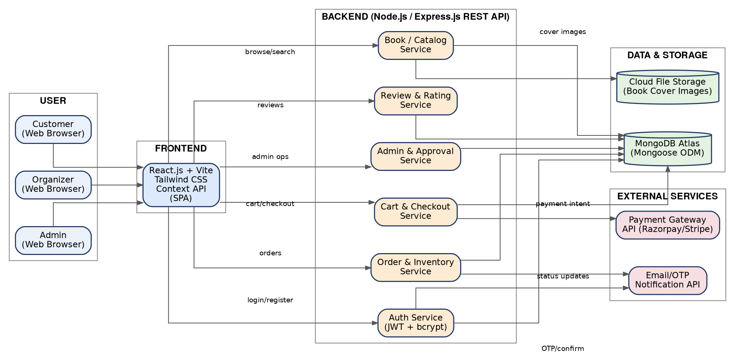

Guidelines followed in this architecture
• All processes are represented as backend service blocks (application logic). • Infrastructural demarcation is shown between Frontend, Backend, Data & Storage, and External Services. • External interfaces (Payment Gateway, Email/OTP API) are indicated separately. • Data storage components (MongoDB Atlas, Cloud File Storage) are shown with cylinder icons. • No machine learning model is used in the current scope.

Table-1: Components & Technologies
S.No | Component | Description | Technology
1. | User Interface | Web application UI for customers, organizers, and admins to browse, purchase, and manage books | HTML5, Tailwind CSS, React.js (Vite), JavaScript
2. | Application Logic-1 | Business logic for authentication, registration, and role-based access control | Node.js, Express.js, JWT, bcrypt
3. | Application Logic-2 | Business logic for book catalog, search, cart, and checkout operations | Node.js, Express.js, Mongoose
4. | Application Logic-3 | Business logic for order processing, inventory updates, and delivery status tracking | Node.js, Express.js, Mongoose
5. | Database | Primary data store for users, books, carts, orders, and reviews | MongoDB (NoSQL, document-oriented)
6. | Cloud Database | Managed database service hosting the MongoDB cluster | MongoDB Atlas
7. | File Storage | Storage for book cover images and other static assets | Cloudinary / AWS S3
8. | External API-1 | Processing of online payments during checkout | Razorpay / Stripe Payment API
9. | External API-2 | Sending order confirmations, OTPs, and status update emails | Nodemailer / SendGrid Email API
10. | Machine Learning Model | Not applicable in current scope (planned: book recommendation engine) | N/A (future scope)
11. | Infrastructure (Server / Cloud) | Deployment of frontend and backend services  Local Server Configuration: Node.js v18+, npm, local MongoDB instance for development  Cloud Server Configuration: Render / Vercel (frontend), Render / Railway (backend), MongoDB Atlas (database) | Local (development), Vercel + Render + MongoDB Atlas (production)

Table-2: Application Characteristics
S.No | Characteristics | Description | Technology
1. | Open-Source Frameworks | Core open-source frameworks and libraries used to build the frontend and backend | React.js, Node.js, Express.js, Tailwind CSS, Mongoose
2. | Security Implementations | Password hashing, token-based session security, input validation, and protection against common web vulnerabilities | bcrypt password hashing, JWT authentication, HTTPS, Helmet.js, express-validator, OWASP best practices
3. | Scalable Architecture | The system follows a 3-tier MVC architecture with a decoupled REST API, allowing the frontend, backend, and database to scale independently; backend services can be split into microservices as load grows | Node.js/Express.js REST API, MongoDB Atlas horizontal scaling, stateless JWT sessions
4. | Availability | Cloud-hosted services with managed uptime, automatic restarts, and database replication ensure the application remains available to users | MongoDB Atlas replica sets, Render/Vercel managed hosting with auto-restart
5. | Performance | Optimized queries with indexing, client-side caching of catalog data, and a fast Vite-based build minimize load times and support concurrent requests | MongoDB indexing, React Query/Context caching, Vite build optimization, CDN for static assets

References
https://c4model.com/ | https://developer.ibm.com/patterns/online-order-processing-system-during-pandemic/ | https://www.ibm.com/cloud/architecture | https://aws.amazon.com/architecture

